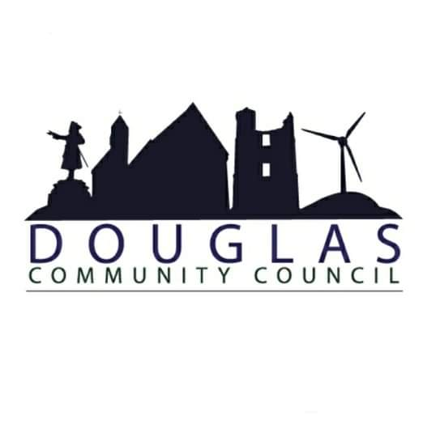

Douglas Community Council
[DRAFT] Minutes of Meeting
Annual General Meeting
7th November 2022, 19:00
St Bride’s Centre

- Present: Kyle MacMillan, James Smith, Kenneth Sludden, Brian Muir, Ashlay Smith, Helen Donnelly, Suzanne Hughes, Keith Burrell, Gary Parker, John Smith, Margaret Currie, Kathleen Nicol
- Apologies: Catherine Tweedie, Councillor Mark Horsham, Councillor Ross Lambie, Councillor Ross Gowland
- Minutes of Previous AGM: Proposed: BM Seconded: KS
- Reports
  - Chairperson’s report: #
“As we complete another CC annual term, the membership is given the opportunity to assess its contribution to community life. The continued hard work and dedication of the membership has served to establish the group as the recognised anchor organisation to effect change and influence local decision making.
The group continues to promote a policy of proactive engagement with other local groups which has had a proactive impact on raising local ambitions and is reinforced by the continued good working relationship enjoyed with our Councillors and various Council departments of SLC who contribute greatly to our work for the betterment of the community.
The CC term has been more difficult than usual as we had to work on the best we could during the pandemic. SLC stopped all fact-to-face meetings, but we managed to continue by video link, which was not as suitable, but we managed. During this period, we had two members resign – Adele Smith and Angela Whitefield but we have recruited two keen and very active members – Brian Muir and Catherine Tweedie. I would like to thank the two members who resigned for their input during their term.
During the term, there have been many small changes and inputs we have done which would benefit our community. But probably one of the main ones was the establishment of the cemetery extension that was completed a few months ago. The work started in 2014 and many phone calls between SLC, D&A and the late Lord Hume have now come together, and our extension is now there.
Another project we are working on now is the LEDS for discounted electricity in the villages. We have been working on this for over a year and all documents have been signed and we are hoping for this funding from Kennoxhead Wind Farm will be used to reduce our electric bills by approximately £200 per annum. Thank you for your work, Kenny.
I would like to take this opportunity to thank all our members for all their hard work over the years and for the support they have given me during this period.”
James Smith, Chairperson
  - Treasurer’s report:
Since JGs resignation earlier in the year, KM has taken on the role of Treasurer temporarily. We now have a draft set of accounts in hand. We are hoping to have them completed in the coming weeks. The CC approve the draft accounts in principle.
The current bank balances are as follows:
Current account: £461.42
Microgrant account: £8.261.97
- Election of Office Bearers: Currently, all CC members stand down. New CC members are as follows:
Brian Muir – Chairperson
James Smith – Deputy Chairperson
Kyle MacMillan – Secretary
Helen Donnelly – Treasurer
Kenny Sludden
Catherine Tweedie
Ashlay Smith
- Constitution: No alterations.
- Adherence to the Scheme and Associated Documentation: No alterations and all CC agree.
- Bank Account: KM to work with HD to change the signatories on the bank.
- Co-option: n/a
- Dates of Meetings:
9th January 2023
13th March 2023
8th May 2023
10th July 2023
11th September 2023
13th November 2023

