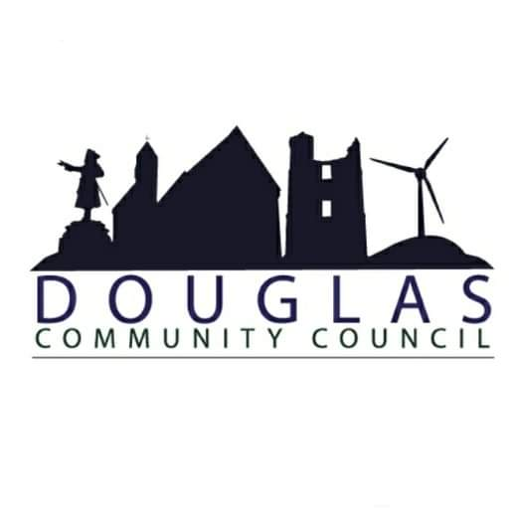

Douglas Community Council
Minutes of Meeting
16th January 2023
19:00
St Bride’s Centre

- Present: Brian Muir, James Smith, Kenneth Sludden, Catherine Tweedie, Kyle MacMillan, Helen Donnelly, Ashlay Smith, David Stobie, Councillor Mark Horsham, Councillor Ross Lambie
- Apologies: PS Stewart McDonald
- Police Scotland Report:
“From 16.12.2022-16.01.2023 Douglas has recorded:
56 Incidents (which can cover all incidents including crimes, flooding’s, lost property etc)
11 Crime Reports of which:
4 have been detected
1 has been undetected
6 are still under enquiry
Over the Christmas/New Year period we assisted our Response Teams in relation to inclement weather in the area.
We were involved in a national initiative, focussing on acquisitive crime (Housebreakings/Theft of Motor vehicles), which saw an increased police presence both on high visibility and plain clothes patrol.
We have increased our social media footprint locally, focussing on road safety and crime prevention.
We are in discussions with local elected members, where we are hoping to host joint surgeries to increase our accessibility to Douglas residents.
We are looking to visit local schools in the New Year to try and promote positive parking and increase engagement with pupils. We have increased training regarding speed guns, quad bikes, and social media awareness.”
Sergeant Stewart McDonald
- Minutes of last meeting: Proposed: KS Seconded: BM
- Matters Arising: n/a
- Correspondence: Email: Ventient Energy, informing us of a planning application submission to extend the operational life of Galawhistle Wind Farm for another 10 years.
- Reports
  - Chairperson’s report:
“Welcome everyone. Trust everyone is well, and we all had a lovely festive period. We have had a busy time since our last meeting in November and I attended meetings with following.
Heritage, Community & Place Workshop, hosted by Banks Renewables. On how local developers can do more to project, enhance and raise awareness of cultural heritage in South Lanarkshire. Affordable Energy Transition Community Workshop hosted by Banks Renewables, Robin Winstanley and Michael Newton and his group looking for a better understanding on LEDS scheme. Pavilion Feasible Study hosted by Douglas Westwater and DCDC. Douglas Westwater, community enterprise director rolled out revised draft copy of proposal for new pavilion. LEDS / RES, Donna and Fran held 2 workshops at St Brides to assist with LEDS applications. Hagshaw Energy Cluster, Western Expansion, public consultation hosted by 3R ENERGY. Wood Group explained how they are working on possible development of Hydrogen plant. CVHA, we had a sit down with Fin Smith and his group to gain a better understanding on housing issues and plans going forward. Douglas Valley Advisory Group, Sarah O'Sullivan rolling out framework action plan on various walks located in neighbouring villages. We also had a group walk through grounds towards biomass plant via old railway.
We had a request to review Lighting between sheltered housing and McColl’s car park. Was contacted and the response from Allan Price, Engineering Officer (Lighting) This section of road is not adopted by SLC and therefore the council has no obligation to light this road. After speaking with colleagues in planning this development did not require a Roads construction Consent. The existing light in this location ended up in the back garden of one of the properties due to the realignment of the adopted footway and had been disconnected. Local Support, followed up on assistance requested by pensioner at blue tower, passed on details of SLC helplines and explained guidelines we are working within as a group. Everything will be covered on agenda. Again, a big thanks to gang for great support and assistance from everyone.”
Brian Muir, Chairperson
  - Treasurer’s report: Signatories have now been changed on the account.
DCC balance: £462.05
MG balance: £4,066.64
- Local Issues
  - School Astro-turf pitch: Funding approved, still on schedule to be completed during summer school break.
  - Kennoxhead Wind Farm: Feedback from Tom Parkyn (Project Developer, Orsted) on 75/25 split. Tom was to arrange a meeting as soon as consent for second extension has come through. DCC concerned about the newly proposed split and aim to challenge for 90% share.
  - Local Housing
We had a meeting with CVHA in December. Fin Smith (Director of Housing) explained they intend to upgrade all housing to new energy standards before re-letting, we have a follow up meeting scheduled for end of Q1.
147 houses in total
28 wooden houses
119 steel houses
48 empty steel houses
SLC setting up Housing Forum. MH, Carol Graham willing to meet CC to discuss. (SLC also looking into renewing road markings in Glespin and Police to conduct speeding survey as requested. JS, community garden in Glespin was renovated and went to waste so does not believe it best to invest further funds. SLC has funding to carry out renovations in these areas.
  - Kirk Brae Improvements: No update, we are still trying to clarify ownership before we can move forward on any upgrade.
  - Local Energy Discount Scheme: Total Number of Eligible Properties 1015
Accepted Applications 557
Applications under query / awaiting documentation 54 (Scottish Power do not accept the vouchers as they do not have a partnership with Pay Point.
Not registered 375
Postal returns 29
Fund Valve £174,780, Contingency £3000, 611 payments of £281 = £171,691, Left over £89
  - Blue Bridge: New boards assembled in December. Sarah O'Sullivan working with various bodies to clarify ownership. Slats on bridge has been repaired but are uneven.
  - Douglas Community Development Company: Draft Business Plan issued for Crabtree Park. Douglas Arms Hotel had some damage to couple windows. JS boarded up as a temporary repair to prevent unwanted entry.
  - CC Noticeboard: Yet to secure funding to complete project.
  - Egerton Traffic Calming: Recent damage to adjacent walls, car wreck and water damage. Will be discussed further at planned meeting with D&A. Project complete – remove from Agenda.
  - BayWa r.e. Funding: CB agreement has been signed off.
  - Hagshaw Energy Cluster – West Extension: Design - 72 wind turbines, solar photovoltaic search areas 50 MW, On-site energy storage 100MW, Green Hydrogen Production Facility 40 MW. Douglas is outside boundary of turbines so only benefits we could possibly receive is via Hydrogen plant.
  - Statkraft – Andershaw Wind Farm: Public Exhibition on West Andershaw took place. Jim advised we had no CB from previous phase.
  - Community Transport: KM suggests that bus route should include Lesmahagow as a stop, even intermittently. MH thinks best option is to try again for X74 to stop at Cairn Lodge. MH to contact Sandra Whitelaw.
  - Gala Day: Engage with David Webb and attend next AGM. HD to contact David Webb regarding funding application support.
  - Healthy Valleys, food bank support: Meeting set up with Amanda at St Brides 23 January. We will also look at model Coalburn use at present. Blackwood Resilience Group set up similar project.
  - Glespin Fun Day: AS wishing to revive Glespin Fun Day. AS to attend meeting with HD and DW to discuss possibility of establishing sub-committee of Gala Day Committee to take this project forward.
  - SMRT Mainshill Funding: Ongoing discussions on how funding can be used. Await feedback from Robin Caldow on outcome of meeting. It was highlighted funding should come under environmental. Hoping to change conditions to allow funding to go to projects such as the Hotel renovation and Crabtree Improvement.
  - Douglas & Angus Estates meeting: MH, would like Cameronian Cairn handed over to Cameronians to allow for funding applications. Would like to see a better path and trees lining it.
- Microgrant Schemes
  - Funds: 3R - £394.57
Gala. - £172.25
REF - £3,500.00
  - Applications:
7th Lanarkshire (1st Douglas) Scout Group – Max. of £500 to cover cost of swimming lessons for Beavers & Cubs. APPROVED
Douglas Old Folks Society - £500 to cover costs of meal for members in February. APPROVED
Douglas Curling Club - £500 to cover costs of anniversary celebrations. APPROVED
Douglasdale Players - £500 to go towards costs involved in this year’s production. APPROVED
All applications made to REF Microgrant Scheme.
- AOCB: BM, £450 quote to build compound around grave in Windrow Woods, Quote obtained from Jim Gold. KM has informed CC that he will have to step back his duties due to Scouting commitments. KS has offered to take minutes of meeting going forward to assist KM.
- DONM: 13th March 2023
- Close of meeting: 21:34

