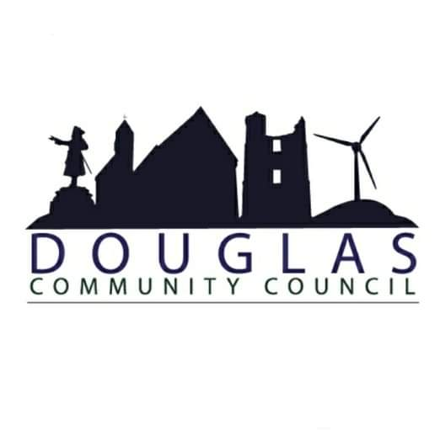

Douglas Community Council
[DRAFT] Minutes of Meeting
13th March 2023
19:00
St Bride’s Centre

1. Present: Brian Muir, Jim Smith. Kyle McMillan, Ashlay Smith, Hellen Donnelly, Cath Tweedie, Councillor Ross Gower

2. Apologies: Mark Horsham, Kenny Sludden, Ross Lambie

3. Police Scotland Report:
“From 13.02.2023-11.03.2023 Douglas has recorded:
75 Incidents (which can cover all incidents including crimes, flooding’s, lost property etc)
9 Crime Reports
We have continued our social media footprint locally, focussing on road safety and crime prevention, and have started advertising joint surgeries with elected members in Larkhall.
We are anticipating extending this to the Douglas area in the near future.
Our local Douglas officers have recently received additional training for local primary school engagement, and we are liaising with SLC Roads Department in relation to issues raised in the area.
We have been working closely with local Housing Officers and local councillors in relation to recent issues raised in the area.
I will contact you once I have more details of joint surgeries in the area, which will give local residents additional access to our officers.”
Sergeant Stewart McDonald
4. Minutes of Last Meeting: Proposed: CT, Seconded : JS

5. Matters Arising: N/A

6. Correspondence: Email from Foundation Forestry Re-scoping letter for long term forestry plan for D&A

7. Reports:

a. Chairpersons Report:

Welcome everyone. Trust everyone is well. Again we have had a busy time since our last meeting in January. 17th January: We had a meeting with Healthy Valleys, Amada Taylor to get a better understanding on HV engagement and local support. 26th January: I was contacted by Real Group, Jason Mitchell on some issues they are having at Woodlands at Douglas West. I went up to site on 26th Jan and met Jason and he explained flooding issues that they are experiencing.
31st January: Myself, Jim and Kenny had a meeting with BanksRenewables, Robin Winstanley, Michael Newton at St Brides on 31st Jan to run over a items prior to consultation event and to make sure we were good with them issuing Bodinglee flyers. 1st February: Myself, Jim and Kenny went over to Coalburn and met with George Greenshields to run over upcoming SPR Hagshaw Cluster Meeting. 2nd February: Myself, Cath, Ashlay and Jim attended DVAG meeting at St Brides.6th February: Myself and Jim attended Gala Day Meeting at St Brides. 9th February: Myself and Jim attended CVHA Coffee morning at St Brides. Myself and Jim had a meeting at St Brides with Orsred, Tom Parkin and Clare Slipper. 13th February: Myself and Kenny Attended DCDC along with Kyle and Jim to see if they would be interested on taking on CB we are looking to get from Hagshaw Cluster. 16th February: Myself and Kenny attended SPR HagshawCluster Meeting at Coalburn. 22nd February: Myself and Jim went along to Affordable Energy Transition - Community Work shop hosted by Banks Renewables at St Brides. 23rd February: Meeting with Martin Millar at St Brides to run over their funding and Winter Lights.

b. Treasurers Report:

Galawhistle £172.07
3REnergy £394.57
REF £2000.00
TOTAL £2566.64 (Microgrant Account)
£301.82 (CC Account)
CC Approved to open new account for Dalquandy Fund.

Local Issues:
a. Kennoxhead Wind Farm
Orsted, Tom Parkin and Clare Slipper issued an update on phase 1 & 2 split

b Local Housing
CVHA to issue update by end of Q-1. They also held coffee morning at St Brides to get any feedback from residents.

c. CC Noticeboard
CC approved to look at funding, also new seat for the area.

d. BayWa r.e. Funding, Dalquhandy Wind Farm
Signed off await bank details.

e. Hagshaw Energy Cluster - SPR
We are working closely with other community groups to form new panel to administer CB.

f. Healthy Valleys, foodbank support
Cost of living event to take place at St Brides on Saturday 23rd March. Cath Tweedie has been working closely HV and has set up 13 groups to attend. Cath applied for funding to cover total costs of event and Scouts to assist with delivering leaflets.

g. Glespin Housing Issues
Ashlay Smith to chase this up at next housing meeting and to report back. Jim Smith to contact housing team also.

h. SMRT Funding (Mainshill)
Await feedback from legal departments

i. Meeting with D&A Estate
Await feedback if any support required from DCC

j. Local Community Transport
RG agrees to local transport is terrible. Use funding which is becoming available to help solve the problems. Current routes provided are not suitable. Main requirements is to gain regular route to Lesmahagow. Ring fence some Hagshaw Cluster funds to tackle local transport. RG to meet with Strathaven group who have funded their own bus route to Glasgow.

k. Galaday Support
JS has been working closely with committee to obtain funding. JS explained very few funds left over from last term. Committee has had signatories on banking changed. Received funding £10,000 from Lottery, £500. BanksRenewables, £1000. Orsted

l. Statkraft - Andershaw Wind Farm
Nothing back from public exhibition on West Andershaw

m. St Brides Car Park Winter Lights
Martin Millar will apply for funding

n. Polish Memorial Garden
Await feedback from Mark Horsham on rearranged meeting.

o. Community Woodland (REAL Group) Douglas West
Waiting on feedback from Mark Horsham on any action that has taken place on broken pipe

p. DVAG - Sarah O'Sullivan
Applications for new members now received. Await details on elected members.

9. Closed / Pending:

a. School Astro-turf pitch
Funding approved, still on schedule to be completed during summer school break.

b. Kirk Brae Improvements
No update, we are still trying to clarify ownership before we can move forward on any upgrade.

c. Local Energy Discount Scheme
Total Number Of Eligible Properties 1015
Accepted Applications 557
Applications under query / awaiting documentation 54 (Scottish Power do not accept the vouchers as they do not have a partnership with Paypoint.
Not registered 375
Postal returns 29
Fund Valve £174,780, Contingency £3000, 611 payments of £281 = £171,691, Left over £89

d. Blue Bridge
New boards assembled in December. Sarah O'Sullivan working with various bodies to clarify ownership.

e. Douglas Community Development Company
Draft Business Plan issued for Crabtree park. Douglas Arms Hotel had some damage to couple windows. Jim boarded up as a temporary repair to prevent unwanted entry.

f. Egerton Traffic Calming
Recent damage to adjacent walls, car wreck and water damage. Will be discussed further at planned meeting with D&A.

g. Glespin Fun Day
Ashlay has advised for 2024

10. Microgrant Schemes;
Douglas Primary£800. Bus transport
Douglas Heritage Museum 3425 day trip
DCC £ Cost of Living Event
Glespin £480 Flower Beds for new season
Happy to use 3R/GW funds to cover funding for Decembers application from Glespin Community Group.

11. AOCB:
JS to co-opt Frazer Goodwin, CC approved. AS request it be minuted of the ongoing traffic issues in Glespin.

12. DONM:
15th May 2023

13. Meeting Closed:
20.53 PM

